Remove Gender from all the forms and lists

Change Pincode to zip code.

Zip code is 5 digit number. Currently you have validation for 6 digit.

**Menu**

In menu, we are using, default icon for home. Can we change it to actual home icon to make it easy.

**Add Dealer**

After selecting state, its keep spinning. Cannot select city and it cannot continue

Also, there is an overlapping text Above state Dropbox.

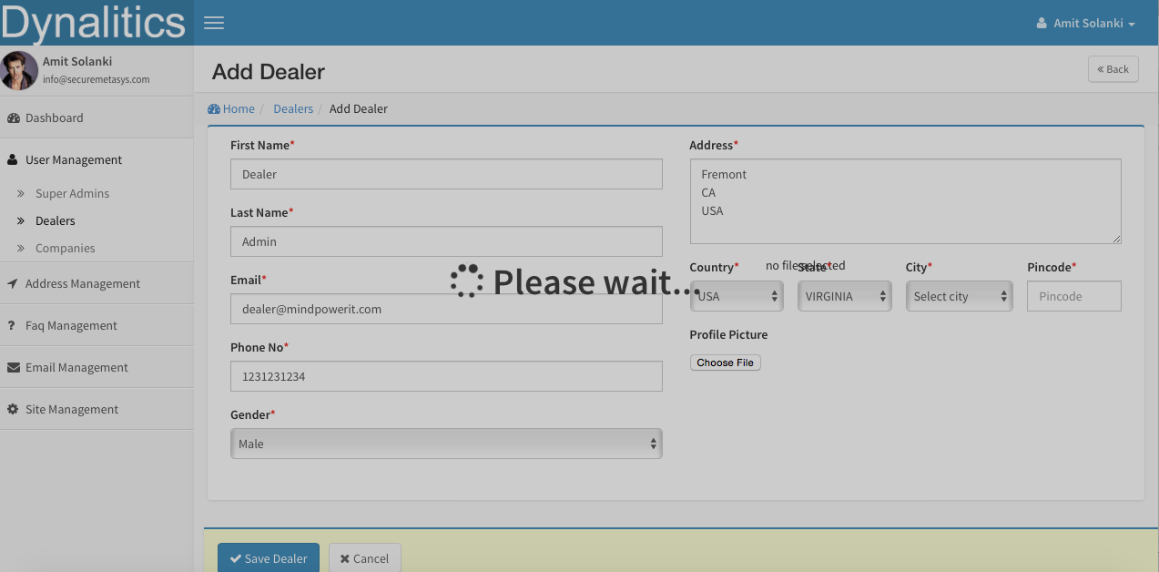

**Add Company**

Also, there is an overlapping text Above state Dropbox. (Same like above)

Company can be created without dealer (To avoid functionality change we can add another option none which will be default)

**Company List**

Missing Dealer (Dropdown) for searching.

Dealer listing page:

Country: Only USA

State: All states in USA

City: All Cities in USA

<http://www.farinspace.com/us-cities-and-state-sql-dump/>

<http://demo.securemetasys.com/dynalitics/dealers/add/24>

There is an overlapping text Above state Dropbox

<http://demo.securemetasys.com/dynalitics/dealers/index/Dealer:24>

Title should not be “Sub Dealer”, it should be “Dealer Users” and Breadcrumbshoudshows (Home / Dealer / Users)

Above “Displaying 1 - 2 of 2 total”we should display that “Dealer Name : [Dealer One]” and remove (Dealer One) from name column. -

Top right corner we have button “Add Dealer” can we change it to “Add User” which means add user to the dealer

<http://demo.securemetasys.com/dynalitics/companies>

Table column title “Total Sub Company” should change “No of Branches”

Please make name column as link, so if user click on it, it will show company detail page. And remove “view company” from action -

Please make dealer name column as link, so if user click on it, it will show dealer detail page.

On this page, we will only display main company account and no need to display type column. Consider company is a group.

When I move mouse over image in action column it shows,

Shows: Change To:

Click here to Edit this employee Edit Company

Click here to reset password Reset Password

Click here to delete this employee Delete Company

Click here to add dealer for this super dealer Add user to Company

Phone number should be formatted – (XXX) XXX – XXXX

<http://demo.securemetasys.com/dynalitics/companies/view/46>

Name will be contact name only (currently it shows company name + contact name)

Remove Gender

Email Address to Email

Phone need to be formatted

Change page title from “Company Detail” to “Company name”

On this page we can merge 2 other pages. So it will have 3 sections.

First section, company detail (currently what we have)

Second, all branches of this company

Third, all users under this company

<http://demo.securemetasys.com/dynalitics/companies/edit/46>

Overlapping text above state

<http://demo.securemetasys.com/dynalitics/companies/add/48>

Title should be “[Company Name] - Add User”

“Company Name” should be Branch Name

“Supar Company” should be “Company Name”

Company type will be branch manager only.

Overlapping text above state

We need to have page for adding branch and adding user to company. (Dealer will have only user)

Title should be “[Company Name] - Add Branch”

“Company Name” should be Branch Name

“Supar Company” should be “Company Name”

Overlapping text above state

We need to have page for adding branch and adding user to company. (Dealer will have only user)

<http://demo.securemetasys.com/dynalitics/dealers>

Please make name column as link, so if user click on it, it will show dealer detail page? And remove “view dealer” from action - Done

When I move mouse over image in action column it shows,

Shows: Change To:

Click here to Edit this employee Edit Dealer

Click here to reset password Reset Password

Click here to delete this employee Delete Dealer

Click here to add dealer for this super dealer Add user to dealer

Phone number should be formatted – (XXX) XXX – XXXX

On this page, we will only display main dealer account and no need to display type column. Consider dealer is a group.

We can combine pages (Dealer detail and Dealer user listing) into one page. So have full page with all the details. So new page will have Top section with dealer detail and bottom will have user listing.

<http://demo.securemetasys.com/dynalitics/dealers/view/21>

Email Address: should be just “Email”,

Please add Phone

Please remove gender

Please make sure if larger image is uploaded as dealer profile then it will be displayed in small section only.